# **The amazing project**

**Group information:**

| **Name** | **ID** |
| --- | --- |
| **Ayman Ibne Hakim** | **2013364042** |
| **Tausif Jahangir** | **2011293042** |
| **Chowdhury Nafis Faiyaz** | **1931841642** |

**Project description:**

The initial goal of the app is to create a platform where the user can upload an encrypted file from his google file and decrypt it using the platform. The app will be designed in such a way so that no one else other than the user to whom the account belongs to can enter in the account.

To ensure security, we will be using google authentication for signup and login. During the signup, the user should take a picture of themself which will later be used for account verification. During login, the user will put his credentials and will get a prompt to take a picture. This picture will be cross checked with the picture given during signup. If both pictures get matched, then the user will be authenticated successfully and will be allowed to enter in his account. After a successful login, the user will be able to import encrypted files from their google drive. They will be able to decrypt and view the file using the platform.

For further security enforcements, there will be an anti spoofing feature in the platform so that nobody gets a chance to get verified as the user by using a picture or video. Along with that, if the user gets out of sight of the camera while using the platform, they will be automatically logged out after a timeout. This can be done by real time face monitoring so that no one other than the designated user is able to view the decrypted version of the file.

## **Software requirements**

## Authenticate with google drive/gmail account

* Take a picture during signing up a user, and use that picture to verify the user every time he wants to login to the app
* Allow to select one or more files from google drive from which he can select/store files.
* The file in the google drive will be encrypted. If anyone want to access the file via google drive, then the user will see the encrypted version
* The file will only be visible when it is uploaded to the webapp/mobile app. Hence the file needs to be decrypted when the user opens it via the app
* Destroy the decrypted version of the file after viewing
* The user can only view the file, he doesn’t need to edit it.
* Person other than who is signed in should not be able to see the file.
* While using the app and viewing the file, if the signed in user gets away from the screen, then the app should be logged out.
* Need of real time face monitoring and recognition and face anti spoofing solution.

**Use case diagram:**

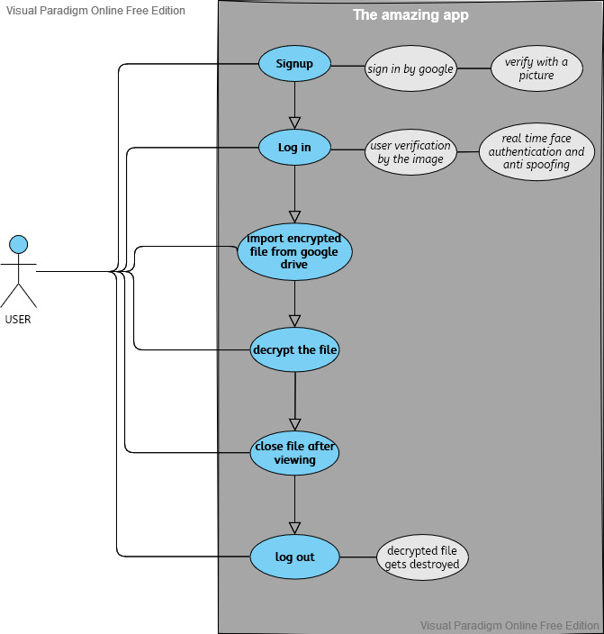

**Flowchart:**

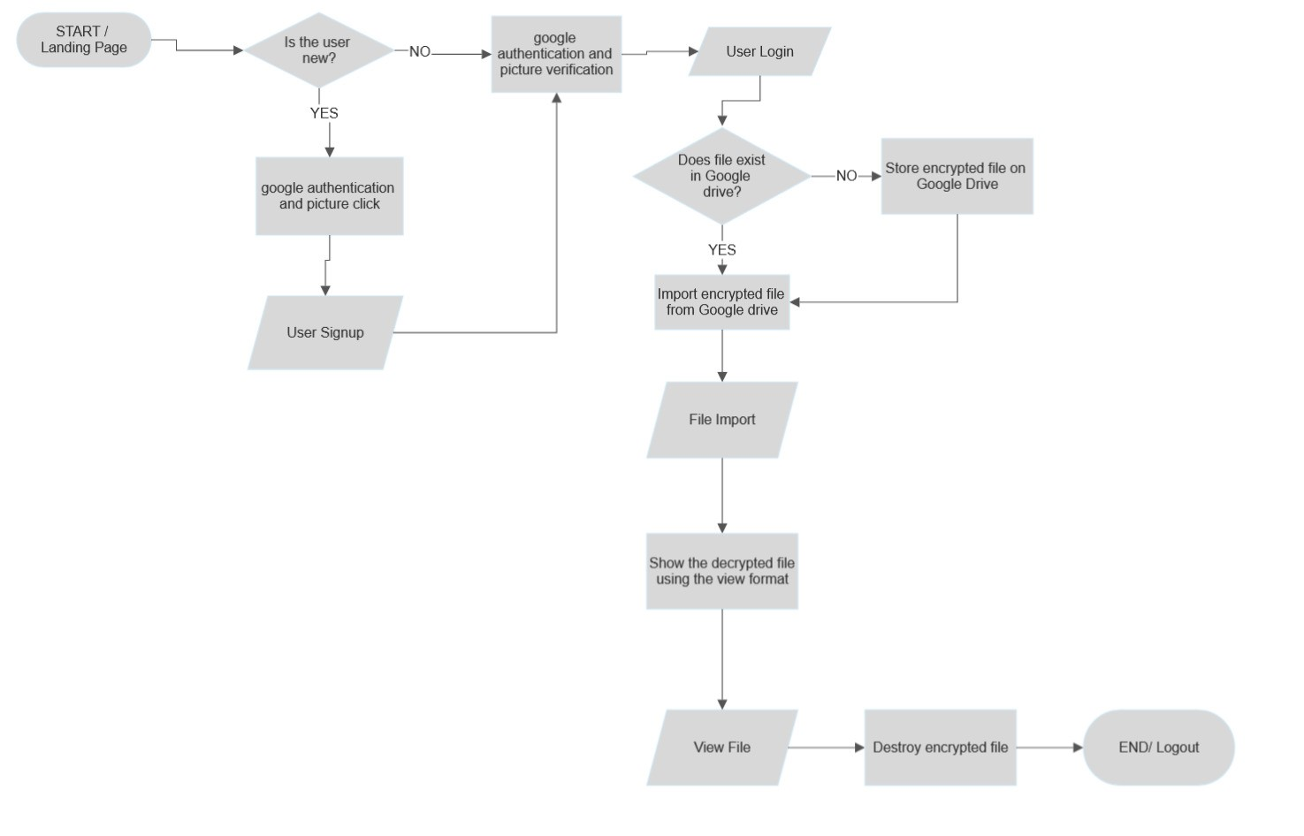

**Project execution plan:**

|  |  |  |
| --- | --- | --- |
| **Week** | **Features and Deliverables** | |
| **Front end** | | |
| Week 1 | 1. Front end(UI) 2. google authentication 3. Creation of Database | * Landing page * signup and login page * import form |
| **Back end** | | |
| Week 2 | 1. Tweaking database 2. sign up and login 3. saving user information in database 4. Connecting with google drive | * Image authentication window. * Storing information in database * importing file from google drive |
| **Security** | | |
| Week 3 | 1. Anti spoofing while log in 2. Verification with the user picture while login | * Implementation of image authentication and verification |
| Week 4 | Encryption and decryption | * Implementation of decryption while importing file from google drive |
| Week 5 | Real time face monitoring | |